OPM - Bug Fix Assembly - Part 2 Deployment Guide

Revision History
Author | Revision Number | Date
yedtoss | 1 | 02/17/2014

Deployment Instructions 3
1. Organization of Submission 3
2. Application Setup 3
3. Ant .Properties File 4
4. Build Scripts Setup 4
5. Database Setup 5
6. Deployment Instructions 6
7. Starting 6
8. Verification 7
8.1. Login 7
8.2. General Guide for testing 8
8.3. Unit Tests 8
9. Resource Contact List 8

Deployment Instructions

Organization of Submission

Folder | Description
conf | Contains application configuration files
lib | Contains dependencies
src | Contains all source files
docs | Contains documentation (this file)
test_files | Contains the test files
log | Contains the test log files
conf/jpa | Contains the JPA mapping and persistence configuration
conf/ejb | Contains the EJB configuration
conf/rules | Contains the business rule definitions
conf/web | Contains the web application configuration files (including spring MVC bean definitions)
conf/ear | Contains application wide configuration (including the datasource definition)
conf/jboss | Contains application changes to the JBoss configuration
src/web | Contains the web application sources
src/java/core | Contains java sources shared across modules
src/java/ejb | Contains java sources for the EJB module
src/java/web | Contains java sources for the front end web application
src/java/tests | Contains java test sources
build-dependencies.xml | Declaration of build dependencies
build.properties | Externalized build configuration
build.xml | Ant build script

Application Setup

The application is tested with the following stack

- Java 6 (http://www.oracle.com/technetwork/java/javase/downloads/index.html)
- JBoss EAP 6.1 (http://www.jboss.org/jbossas/downloads/)
- Ant 1.8.1 (http://ant.apache.org/)
- PostgreSQL 9.2.4 (http://www.postgresql.org/)

The following 3rd party libraries are packaged with the submission
- Drools 5.5
- Jackson 2.3.1
- Spring MVC 3.2.3
- Spring Security 3.1.4
- Hibernate 4.2.3
- Joda-Time 2.3
- JUnit 4.10

Ant .Properties File

Property Name | File property is stored | Example Setting
jboss.home | build.properties | C:/Downloads/jboss-eap-6.1
loggerName | build.properties | gov.opm.scrd
supervisorRoleName | build.properties | supervisor
adminRoleName | build.properties | Admin
defaultPreferenceId | build.properties | 1
defaultReportGenerationDataId | build.properties | 1
log_dir | build.properties | C:/Downloads/opm_log
pendingPaymentStatusIds | build.properties | 2,4,6,8,10,12,14,16,18,20,22,24,26,28
approvedPaymentStatusId | build.properties | 29
disapprovedPaymentStatusId | build.properties | 30
postedPendingApprovalStatus.id | build.properties | 1
postedPendingApprovalStatus. name | build.properties | Posted - Pending Approval
redepositPeriodType.id | build.properties | 1
redepositPeriodType. name | build.properties | Deposit (D)
dedepositPeriodType.id | build.properties | 2
dedepositPeriodType. name | build.properties | Redeposit (R)
csrsRetirementType.id | build.properties | 2
csrsRetirementType. name | build.properties | CSRS
successCalculationStatus.id | build.properties | 1
successCalculationStatus. name | build.properties | Success
db.driver | build.properties | org.postgresql.Driver
db.url | build.properties | jdbc:postgresql://localhost:5432/scrd
db.user | build.properties | postgres
db.pass | build.properties | 123456

Build Scripts Setup

build.xml – compiles, packages and deploys the application
Main targets:

clean removes all generated files
compile-core compiles shared java sources
compile_tests compiles java test sources
test run the test cases
compile-ejb compiles EJB java sources
compile-war compiles web application java sources
configure-ear performs replacement of values for EAR configuration files
configure-ejb performs replacement of values for EJB configuration files
configure-war performs replacement of values for web app configuration files
db-clear clears the contents of the tables
db-create creates the tables and sequences
db-drop drops the tables and sequences
db-test-data recreates the test data
deploy deploys the EAR artifact
deploy-jdbc-driver copies the jdbc driver module into jboss
dist-core creates the core distribution
dist-ear creates the EAR artifact
dist-ejb creates the EJB distribution
dist-war builds the war file

Default target: deploy

Database Setup

Note: for some steps, you can use the ant script to execute them, but make sure you configure the build.properties first.

- Setup PostgreSQL 9.2.4
- Create the database “scrd” using your client. (You may change the DB name, but update your JDBC URL accordingly)

- Execute script src/sql/create-schema.sql and src/sql/triggers.sql to create the required objects (“ant db-create” will perform the same step)
- Execute “ant db-test-data” to insert test data

Setup Database Driver module on JBoss

- Copy conf/jboss/modules into the modules folder of your EAP installation -${jboss.home}/modules/system/layers/base (“ant deploy-jdbc-driver” will perform the same step)
- Add the following entry to ${jboss.home}/standalone/configuration/standalone.xml just after the h2 driver declaration on the datasources/drivers subsystem

<driver name="postgresql-jdbc4" module="org.postgresql">
<driver-class>org.postgresql.Driver</driver-class>
</driver>

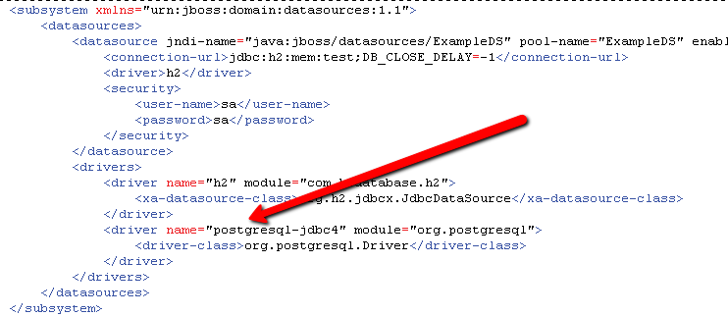

Note: This step can also be done via the jboss command line interface with the following command:

/subsystem=datasources/jdbc-driver=postgresql-jdbc4:add(driver-name=postgresql-jdbc4, driver-class-name=org.postgresql.Driver, driver-module-name=org.postgresql)

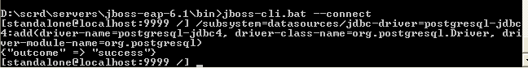

Cleanup scripts: (execute only when done with testing)
• When needed, execute src/sql/clear-data.sql to clear the database tables (“ant db-clear” will perform the same step)
• When needed, execute script src/sql/drop-schema.sql to delete all application objects (“ant db-drop” will perform the same step)

Deployment Instructions

- Modify build.properties to reflect the deployment environment settings. (log_dir must be an existing directory)
- Setup the database as described in the previous section
- Execute “ant deploy”

Starting

Start JBoss. The application is automatically started when the JBoss server is started.

You can start JBoss by going to directory jboss-eap-6.1/bin. Then execute standalone.bat or standalone.sh depending on your OS.

Please note that you may receive a warning (JBAS011054) regarding EAP 6.1 and Spring 3.2.3, you may safely ignore this warning per

https://community.jboss.org/thread/231638?start=0&tstart=0

Verification

Follow deployment steps and start the application. Note that for testing it is recommended to run following command when deploying
ant db-drop
ant db-create
ant db-test-data

When started, open the default URL in your browser http://localhost:8080/scrd/, this should show you the pages.

Note: you may want to turn on DEBUG logging on the server, just add following line to the server configuration (jboss-eap-6.1/standalone/configuration/standalone.xml) under the logging subsystem – make the changes the before starting the server:

<logger category="gov.opm.scrd">
<level name="DEBUG"/>
</logger>

Make sure you change the threshold of the appender to DEBUG too.

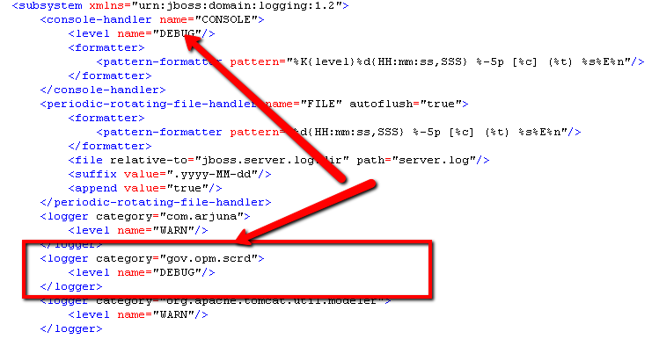

Login
- Open http://localhost:8080/scrd, use “user1” and “123456” to login:
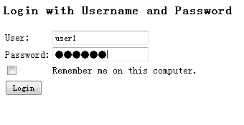

General Guide for testing

Download the bug fix list here http://apps.topcoder.com/wiki/download/attachments/93159486/OPM+SCRD+Issues+List+02+10+2014.xls

Repeat all the steps in each Minor and Trivial Bugs (column F) . Verify that the bug is resolved.

Unit Tests

Run ant test. Note that the ant tests took up to 1.7 GB of RAM in my system. Don’t limit ant memory or increase it accordingly. Also make sure Java process can use up to 1.7 GB of memory.
For example you can use ANT_OPTS and JAVA_OPTS environment variables with the value “-Xmx2048m –Xms1024m”. You might need to use a 64 bits Java.

Make sure you are connected to Internet before running the command otherwise you will get xml drool:kagent error for example.
You should get

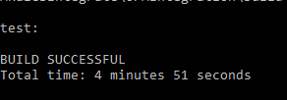

Resource Contact List

Name | Resource Email
yedtoss

